**S/C/6 – Maintenance of Safety Zone at Street-works**

**Incident Summary**

A Repair Team were engaged in leakage investigation works near to an exit from a filling station. The vehicle was parked at the side of the road with a Digger trailer behind it. SLG had been installed. One of the team members needed to climb into the trailer to assist with the fitting of an accessory to the digger. When finished, the operative climbed out of the side of the trailer into the safety zone (marked out with cones). A 3rd party car encroached on the safety zone, hitting cones and hitting the operatives hand sufficiently hard that the car’s mirror was dislodged and hanging off. The car failed to stop.

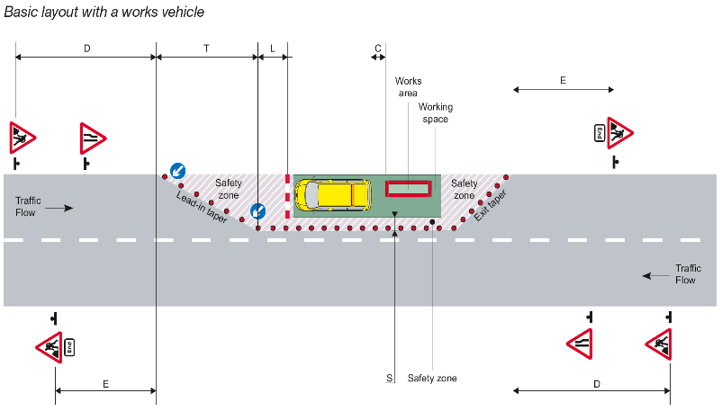

**Key Learning Points**

* The SLG was installed with a priority of keeping 2-way traffic flowing rather than protecting the operatives on site.
* The trailer could have been parked away from the road and hence away from the traffic hazard.
* Provision of a Safety Zone is not just about complying with the “Red Book”, it is about providing a sterile buffer between the work area and passing traffic.
* Not all operatives are clear on the need to avoid being in the Safety Zone unless maintaining the SLG itself.

**Actions required:**

* Do not enter the safety zone in the normal course of work. Materials, equipment and vehicles must not be placed in this zone. You should only enter the safety zone to maintain cones, barriers and other road signs.
* Ensure that Safety Zones are set out in line with the dimensions set out in the Red Book (inside back cover).
* Avoid stepping over the sides of trailers, use the ramp for access and egress